12 February 2017

EPBC Referrals

RE: URGENT - EPBC 7817 Contolled Action MIRVAC
( Teviotr Rd, GReenbank Rd , Brightwell St Greenbank )
Dear Referrals Officers,
I would like to bring to your urgent attention that the Queensland Department of Infrastructure Local Government and Planning ( DILGP) on the 7th February 2017, approved the operational works and removal of vegetation for a caretaker’s dwelling and for bushfire reduction on a MIRVAC property at 96 – 102 Brightwell Street , Greenbank ( DEV 814). This property lies within the area mapped by MIRVAC as AREA 3 ( EPBC 7817 & DEV 768) which is now under a controlled action ( Federal Government Decision Notice dated 15 December 2016 ).
BACKGROUND
Development application for operational works – removal of significant vegetation for animal keeping and husbandry ( caretaker’s dwelling)
DEV 814 - 96 – 102 BRIGHTWELL ST , GREENBANK ( LOT 205 on RP845844)
The proposed caretaker’s residence is located within the northern extent of the MIRVAC site. The application area adjoins Brightwell Street to the west, an existing rural residential property to the north ( 88 Brightwell St ) , vegetation to the east and a power line easement to the south. The proposal involves clearing of vegetation to establish a 0.22ha building envelope for the caretaker’s dwelling (Primary Clearing Area) and an additional 20m fuel reduction zone for bushfire management. Access is intended to be provided by 6m egress paths . Figures 1 & 2 are from the Environmental Management Report by Saunders Havill Group .

FIGURE 1 – PROPOSED LOCATION OF CARETAKERS PROPERTY ( red star) at 96 – 102 Brightwell St within the proposed MIRVAC DEVELOPMENT ( red line boundary) . The 275 kv Powerlink easement is shown in the north of Figure 1 and runs west to east across the northern part of the MIRVAC property.
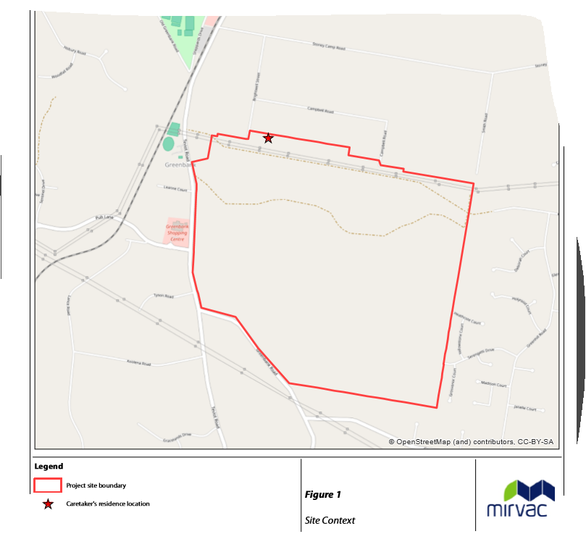

FIGURE 2 – AERIAL IMAGE OF PROPOSED CARETAKER’S DWELLING OFF BRIGHTWELL ST
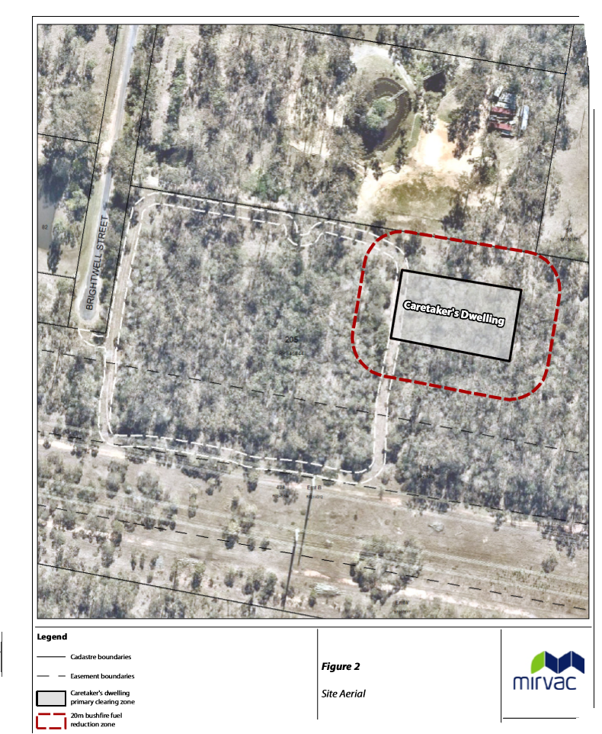
SOURCE: Environment Management Report ( Saunders Havill Group)

REASONS FOR OBJECTION TO DILGP APPROVAL
- The approval for removal of vegetation by Economic Development Queensland has approved the removal of vegetation ( DEV 2016/814) at 96- 102 Brightwell St Greenbank. 96-102 Brightwell St is part of MIRVAC AREA 3 ( DEV 2016/768) which is currently subject to Federal Government Controlled Action ( EPBC 7817) ( Environment Protection and Biodiversity Conservation Act).
Why has the Queensland Government given approval for this action BEFORE any Federal Government approval for Area 3 ?
- The location of 96-102 Brightwell St is known to be associated with rare and threatened species listed by the Federal and State Government e.g. spotted tail quolls, koalas, powerful owls , wallum froglet, greater gliders, glossy black cockatoo
Why is the vegetation at 96-102 Brightwell St not being protected ? It adjoins and connects to surrounding known habitat being used by the above species.
- Past community sightings and dead specimens of spotted tail quolls ( a threatened species in Queensland, endangered under EPBC Act) have been located close to the northern section of the MIRVAC property and close to the Powerlink easement which is close to the caretaker’s dwelling. Sightings have occurred to the east, south east, west , north-west and south-west of this location at Brightwell St and the MIRVAC property. All local sightings of quolls have been located within 150 metres of waterways, water sources ( including but not limited to Norris Creek, Chambers Creek, Oxley Creek and its tributaries , unnamed waterways of the Logan River and Logan River), Scrubby Creek and Sandy Creek ( Ipswich City Council) . the Logan and Albert conservation Association INC has previously communicated extensive comments in relation to the spotted tail quoll in relation to EPBC 7817 during the public comment period in December 2016.

- Locations of past spotted tail quoll observations include –
- Live quoll sighting 28 January 2012 - In the middle of Teviot Rd ( south of Leanne Court) S 27.73472 E 152.98491
- Live quoll sighting Winter 2010 -Greenbank Rd NORTH MACLEAN ,S 27.76377 E 152.99737
- Live quoll sighting /08/05 – south end of Campbell Rd ( Greenbank) just along the Powerlink easement ,S 27.73075 E 153.00369
- 06/03/06 Teviot Rd GREENBANK, S 27.74823 E 152.98601 - Road kill 1m off road opposite Koolena Rd
- Live quoll sighting 29/07/06 Rep 30/07/06 - Koolena Rd GREENBANK,S 27.74784 E 152.98019
- Road kill quoll 21/06/05 - Centre line Mt Lindesay Highway 50m south of Carter Rd turnoff ,S 27.73650 E 153.02759 Sub-adult male ( now in Qld Museum collection)
- Winter 2004 ,Outside Munruben Works depot Greenhill Rd MUNRUBEN , S 27.75575 E 153.01321
- Additional quoll sightings west of Teviot Rd
Why is the vegetation not being protected for spotted tail quolls and other threatened species which are known and sighted in the local area ?
Why is the Queensland Government not protecting habitat for threatened species in SE Queensland, especially in the Greater Flagstone Area?

- The northern location of this property with vegetation that connects to properties further north, east and west, as well as the MIRVAC property with connected habitat in the south, makes this location and vegetation very important for connectivity of habitat in the local area and regional landscape.
This property at 96-102 Brightwell St lies within a Regional Corridor and Logan City Council Biodiversity Corridor which extends through the site to the east and west. .
- EPBC 6941 - STATEMENT OF REASONS
An EPBC statement of reasons for North Maclean Industrial area ( EPBC 6941) on 23 May 2016 included point 35 in relation to spotted tail quolls in the Greenbank/North Maclean / Munruben area -
“The delegate considered that there is likely to be a low density population of the spot- tailed quoll in the region, and that an area 1-5 km to the north of the ( WEARCO )site ( EPBC 6941) is likely to be an important east-west habitat corridor.”
The property at 96 – 102 Brightwell St and the whole of the Mirvac property ( EPBC 7817) is located within this 1-5 km location.

- The vegetation at 96-102 Brightwell St and surrounding this property is mapped as SEQ Koala Habitat Values - Medium Value Bushland and Medium Value Rehabilitation. Offsets will not prevent the local extinction of koalas in the Greenbank Area or in SE Queensland. The removal of any habitat is a KNOWN threat to the survival of koalas. Reducing habitat connectivity in the local landscape will not ensure the survival of koalas in this location of Brightwell St or Greenbank.
Why is the vegetation not being protected for koalas which are known and sighted in the local area ?
Why is the Queensland Government not protecting koalas in SE Queensland, especially in the Greater Flagstone Area?
The resident at 88 Brightwell St (on the northern boundary of 96-102 Brightwell St) has previously observed koalas on numerous occasions at that property. Other local residents have as well. The resident at 88 Brightwell St had one sighting in September / October 2013 and other neighbours saw the koala at that time. The koala visited for a few days in various gum trees. Prior to this sighting, the residents would notice a koala every few years.
Prior to November 2010 there was a prolonged dry period in SE Queensland and local residents have reported seeing less koalas in that dry period, than in the wetter years since that time. Very few local residents report their koala sightings. However, in the week of 17 October 2016 a koala was reported as road kill from Stoney Camp Rd. Since the wetter conditions since November 2010, local residents have reported more observations of koalas around Norris Creek and Munruben ( along and west of Greenhill Rd and west of the Mt Lindesay Highway ) .

The statement on p 6 ( Saunders Havill Group Environmental Management Report) “no koalas or evidence of koalas were observed during the tree survey” reveals the lack of long term fauna studies undertaken in the area from Mt Lindesay Highway west to Spring Mountain. The Environmental Management Report does not acknowledge the importance of this site because it is connected to the koala habitat area to the east, west and south of this location. The habitat to the south and east and west is subject to a Federal Government Controlled Action, and as such no approval by State Government should be being given at this stage when there has been no final determination by the Federal Government.
- The vegetation listed in the Environment Management Report for the site at 96 – 102 Brightwell St includes ‘Of Concern’ Vegetation included koala food source trees such as Eucalyptus tereticornis ,Angophora leiocarpa,Corymbia intermedia, Lophostemon suaveolens. Acacia vegetation provides food sources for glider species and Allocasuarina littoralis vegetation provides an essential food source for glossy black cockatoos ( which feed only from this species) .

The vegetation is being proposed to be cleared for the footprint of the caretakers dwelling and for bushfire management . The vegetation being proposed to be cleared is Of Concern remnant vegetation (RE 12.9-10.2/12.010.7) and non-remnant vegetation (p6). The Of Concern vegetation is currently connected to patches of endangered vegetation on the adjacent northern property where there is a current residence on 88 Brightwell St and where there has been sightings of koalas on that property.
Why is the vegetation not being protected for koalas and other threatened species which are known in this local area ?
Why is the Queensland Government not protecting koalas in SE Queensland, especially in the Greater Flagstone Area?

- The Vegetation should not be removed, there has been no Federal Government decision for this matter at an EPBC level. 96 – 102 Brightwell St is part of the MIRVAC proposed development ( EPBC 7817) . It is part of AREA 3 which is presently subject to a Controlled Action by the Federal Government.

- Objection to the Location of the Caretaker’s Dwelling
“It is noted that the caretakers dwelling on the land is not a component of assessable development as it is ancillary to an existing use right on the land (animal keeping & husbandry). The location of the new caretakers dwelling was selected based on a number of criteria including:
Development staging (so the new house won’t have to be moved as development progresses); Ease of access; Overlooking of balance of site; and Limiting disturbance to significant vegetation” ( Urbis p 3)
The proposed location of the caretaker’s dwelling could be located elsewhere and not in Brightwell St , subject to future development approvals on the MIRVAC property ( EPBC 7817) . Mitigation should be considered in the first instance – the caretaker’s dwelling should not involve the removal of any vegetation. The proposed location for the caretaker’s dwelling no where near the Area 1 ( MIRVAC SITE) which is proposed to the east of the intersection with Teviot Rd and Pub Lane for initial development on the MIRVAC site. This caretaker’s dwelling is proposed to be downhill of the MIRVAC site, so the caretaker would not be able to see the MIRVAC site without driving to it. The location is not suitable.
- If new development is proposed, areas of environmental value should also be buffered.
How are buffers being provided in this proposed removal of vegetation?
- There has been no overall TRAFFIC STUDY released to the public for comment that reveals the enormity of the traffic being proposed with this new development in the area of Greenbank and North Maclean.
I am aware that approximately 3300 homes are being planned for as part of the MIRVAC AREA 1 development – this could conservatively indicate an additional 6600 vehicle movements per day just associated with the MIRVAC site ( AREA 1 opposite Greenbank shops on Pub Lane) . Other proposed developments, such as the North Maclean Industrial Area proposes an additional 4500 vehicle movements per day through the North Maclean Industrial Area site and local roads. With additional new development at Spring Mountain, Pub Lane ( old Teviot Downs site) and New Beith the cumulative traffic impacts will have negative impacts to drivers, public safety, and wildlife.

I request that your section investigates this matter to ensure that EPBC interests and threatened species are being protected.

Your sincerely,
Anne Page
M ENV MGT BA HONS ( GEOGRAPHICAL SCIENCES) DIP ED
President
Logan and Albert Conservation Association INC
22-28 Stanley Court MUNRUBEN 4125
PO BOX 557, Beaudesert Qld 4285
EMAIL – mkpage@bigpond.com
PH: 07 3297 0624

